Instructions To Apply For Graduate Fellowships 2019-2020

Important Note: It is the responsibility of the applicant to be aware of the fellowships deadlines

Please be aware of the Banner self-service Session time out, which is 5 minutes while filling your application. The session time out occurs when no action is taken on the SSB page after login.

New applicants who are in the process of being admitted or have already received their admission decision must follow Step I to sign up to the AUC Banner system.
You will NOT be able to submit a fellowship application unless you have received a valid AUC ID number.
Continuing students who are currently enrolled at AUC do not need to go through Step I and can go directly to step II.
The system will not allow you to apply to fellowships unless we have your graduate application record.
If you have already, or recently submitted your graduate application and received a Student Identification Number please allow 10 days before starting the online fellowship web application process.
If one week after receiving your Student Identification Number the system still does not allow you to start the process please contact gradwebapp@aucegypt.edu for technical assistance.

Step I: Create a Banner Account for New Applicants
- Visit the following URL
https://signup.aucegypt.edu/EmailProvisioning/Prospective/CreateProspective.aspx

- Enter Your Student ID that you have received when applying to a graduate program at AUC

- Choose your Birthdate from the Calendar Icon.

- Click on Create Account Button.

- Your banner account will be created and you will receive a message stating your username and password.
- Keep this window open in your browser or make sure to copy your login credentials. Save these login credentials to check on your fellowship application status at a later time. New applicants should not signup more than once to avoid system error.

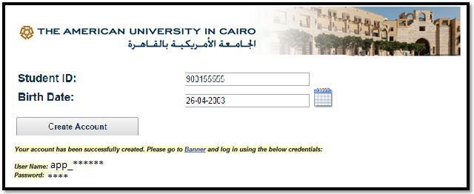

- Click on Banner Hyperlink to be directed to Banner Self-Service Pages at AUC

- Now you will be able to login to AUC Self Service.

Step II for All (new applicants and already enrolled students)

- Click on Enter Secure Area.

- Enter your username and password in the below fields and click Login
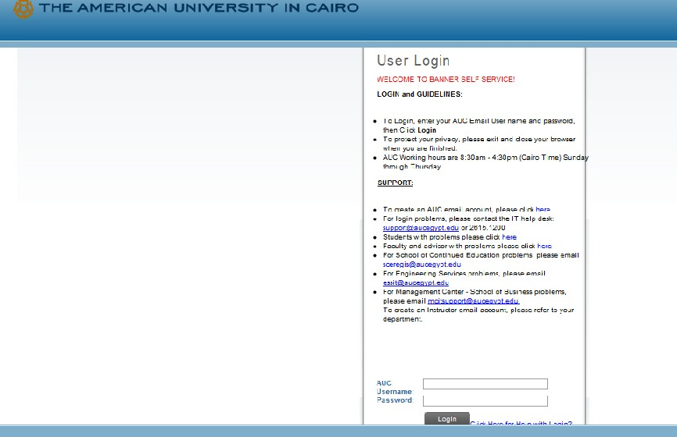

You are now successfully logged into AUC Banner Self-Service.

- Click on the Student Awards and Financial Aid button.

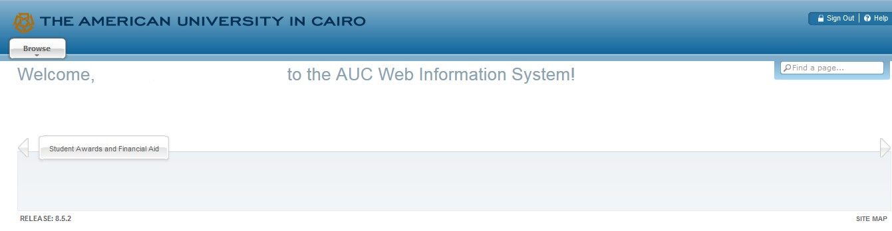

- Click on Apply for Student Aid
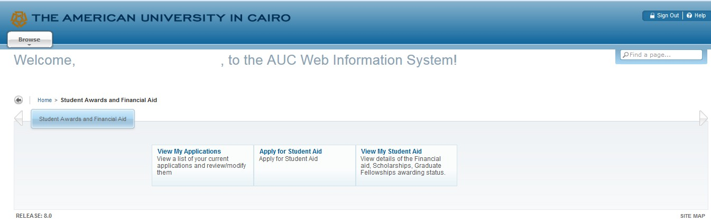

- Choose the Aid Year and Aid Period as below

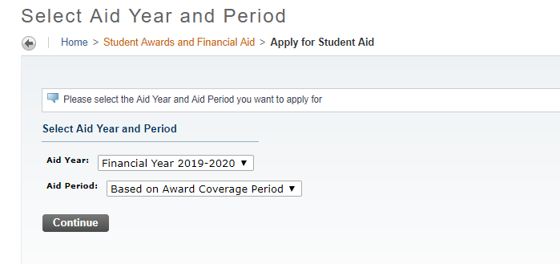

- Select from the list “Graduate Fellowship Application – Fall 2019”

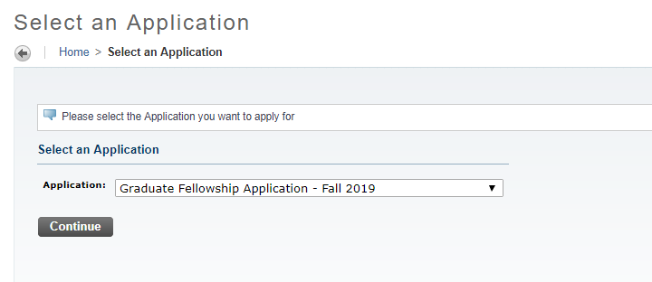

Or If you fit the eligibility requirements of the Vanessa B. Korany thesis Support fellowship “

You may select “Graduate Thesis Fellowship Application”.

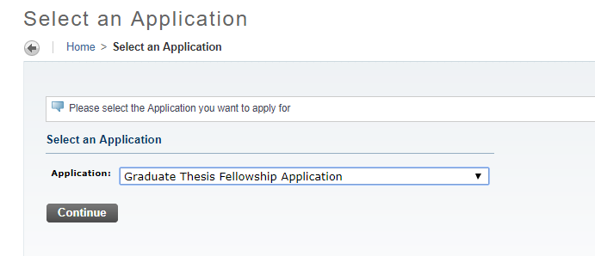

Press Continue

- Complete each section of the application. It is mandatory to check the box “Mark this section Complete”. When the section is completed press Continue.
6
- Make sure you DO select the fellowships you need and mark, "Apply to this award" in the fellowships you choose.

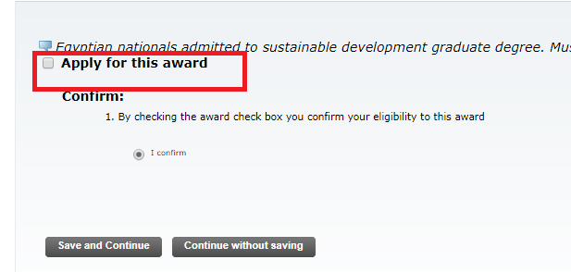

- Press the “submit” button after finishing all required sections.

- Please read the awards eligibility criteria section very carefully in order to choose the appropriate fellowship. It is essential to apply to up to three fellowships only.

- If you select more than 3 fellowships your web application will not be considered.

- It is important to view the AUC self-service web site to check the status of your application regularly

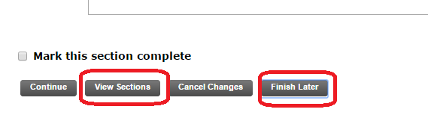
- If you want to finish your application at a later time; please press the “Finish Later” button. If you want to view the application sections, press “View Sections” button

- If you pressed the “Save Later” button and you want to go back to fill the rest of your application, kindly press the “View/ Modify” link
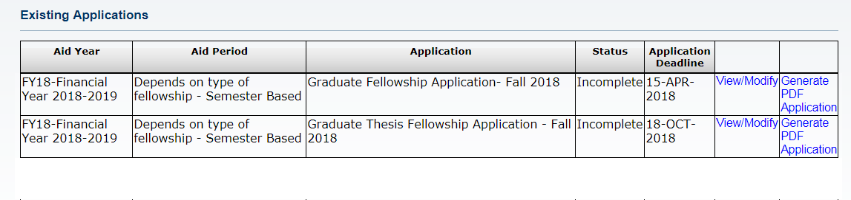

- After reviewing all sections, kindly do NOT forget to press “Submit” button. By pressing the button it will be ready for evaluation

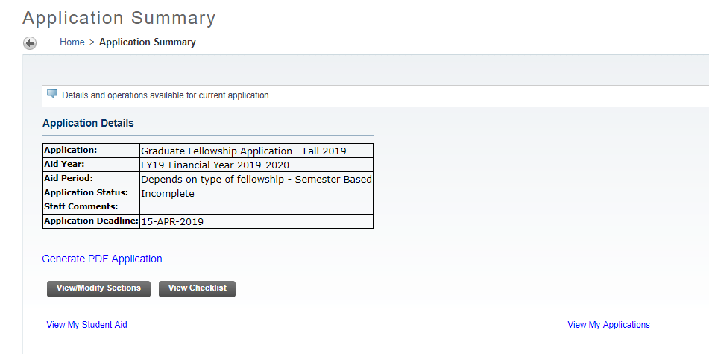
IMPORTANT NOTE:
You can select “Graduate Fellowship Application” only once which is the first time you enter the system. If you decide at any time to continue the application process you will need to press on “View My application” button

- Once the application is submitted and follow-up on your application status using SSB; kindly Press the “View My Applications” Button.
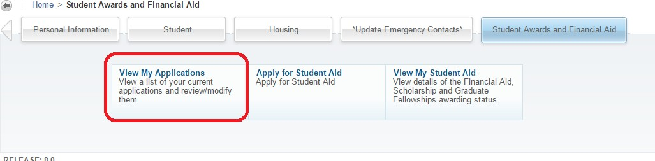

If any, comments will be displayed in the field below

Important Note: It is the responsibility of the applicant to be aware of the fellowships deadline

